**Task list need to keep its state**

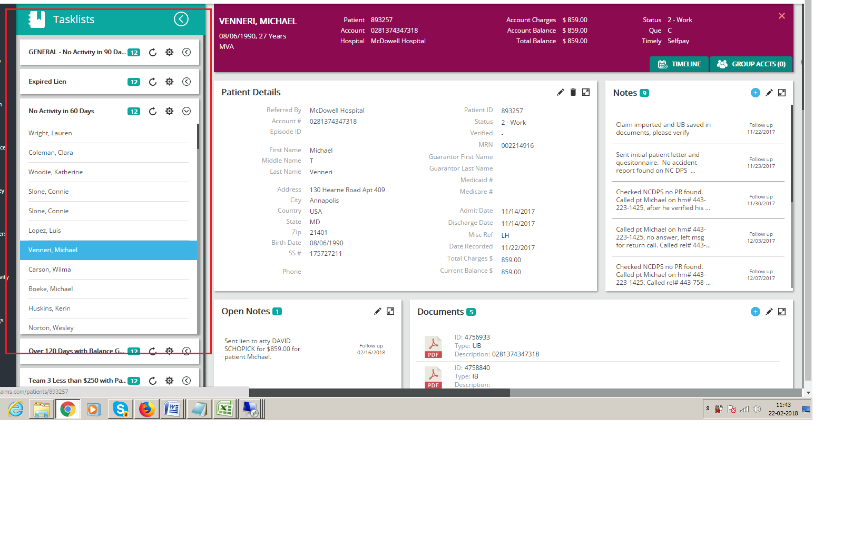

Now if i open a menu like search and come back and click home then the task list is go back to its initial state.. we need to keep the state like the top image and if possible ten show the last opened patient in some indicator or color

